Materials needed: Fabric for front and back (print one side and solid the other), cutting mat, rotary cutter, thread, pellets, large bowl (think huge mixing bowl), measuring cup, dissolvable tape - optional, kitchen scale - optional.

Sizes will be color coded and listed like this 3lb (5lb, 7lb, 9lb, 11lb, 13lb)

- Fabric should be cut at 36” (36”, 54”, 63”, 63”, 72”) and be 44” – 45” wide. I leave the selvage on; you can choose to do what you want.
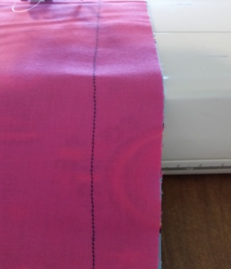
- Sew it right sides together on three sides with a 1” seam. You will want both selvage sides and one cut side sewn. Leave about 1 ½” on the top of each side to allow for finishing the top.
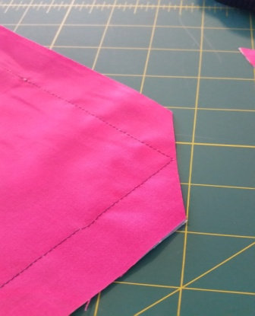
- Cut the bottom of the two corners on an angle to allow for a crisp corner.

- Turn right-side out and iron.

- From the top mark 1 ½” down. This is so you know where to start and stop all of your stitches.

- Starting at the top of one side, at your premarked line, sew a top stitch around the three already sewn sides. This stitching needs to be right on the edge of the fabric (no more than a 1/8" seam).
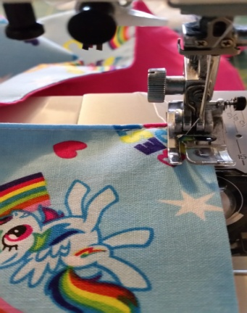

- Sew a second stitching line, ½” from edge, around all three sides again.
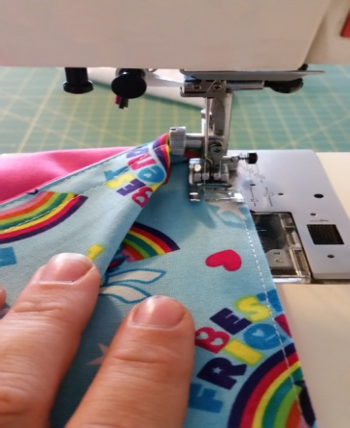
- Sew a third line using a triple stitch/stretch stitch/knit stitch, ¾” from edge, around the three sides.

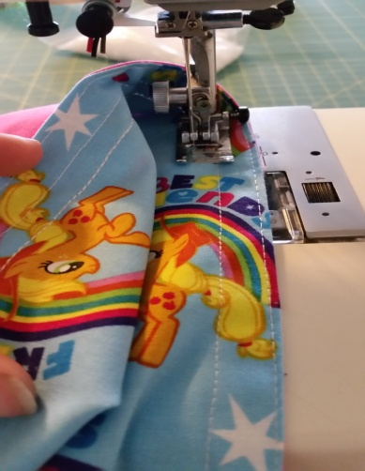
- Measure the length between both of ¾” triple stitch line on the short side. Take that number and divide it by 6 (6, 5, 6, 6, 7). This is the spacing to mark the lines for the columns.

- Mark the lines for the columns.

- Stitch the columns with a triple stitch/stretch stitch. This completes the shell of the blanket.

- Measure the length between ¾” triple stitch lines and the premarked line. Take that number and divide it by 4 (4, 7, 7, 9, 9). This is the spacing for the rows.

- Mark the lines for the rows.

- Using a full 2/3 cup (3 oz.) fill each column with pellets. Please weigh your 2/3 cup first to ensure you have the proper weight. If it weighs more than 3oz you may use a 1/2 cup, but again weigh it first. We either use Quality Poly Pellets from qualityplasticpellets.com or buy bags from JoAnn's when on sale.

- Triple stitch/stretch stitch on the first row from the bottom line.

- Continue the previous two steps for next 3 (3, 6, 6, 8, 8) rows.

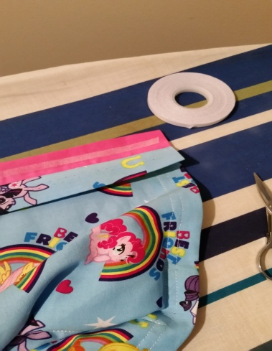
- The last row, fill each column with pellets. Fold down the extra fabric to the already stitched edge lines and columns, and iron it to get a crisp edge. You may use a dissolvable tape between the front and back fabrics to help keep the pellets in.
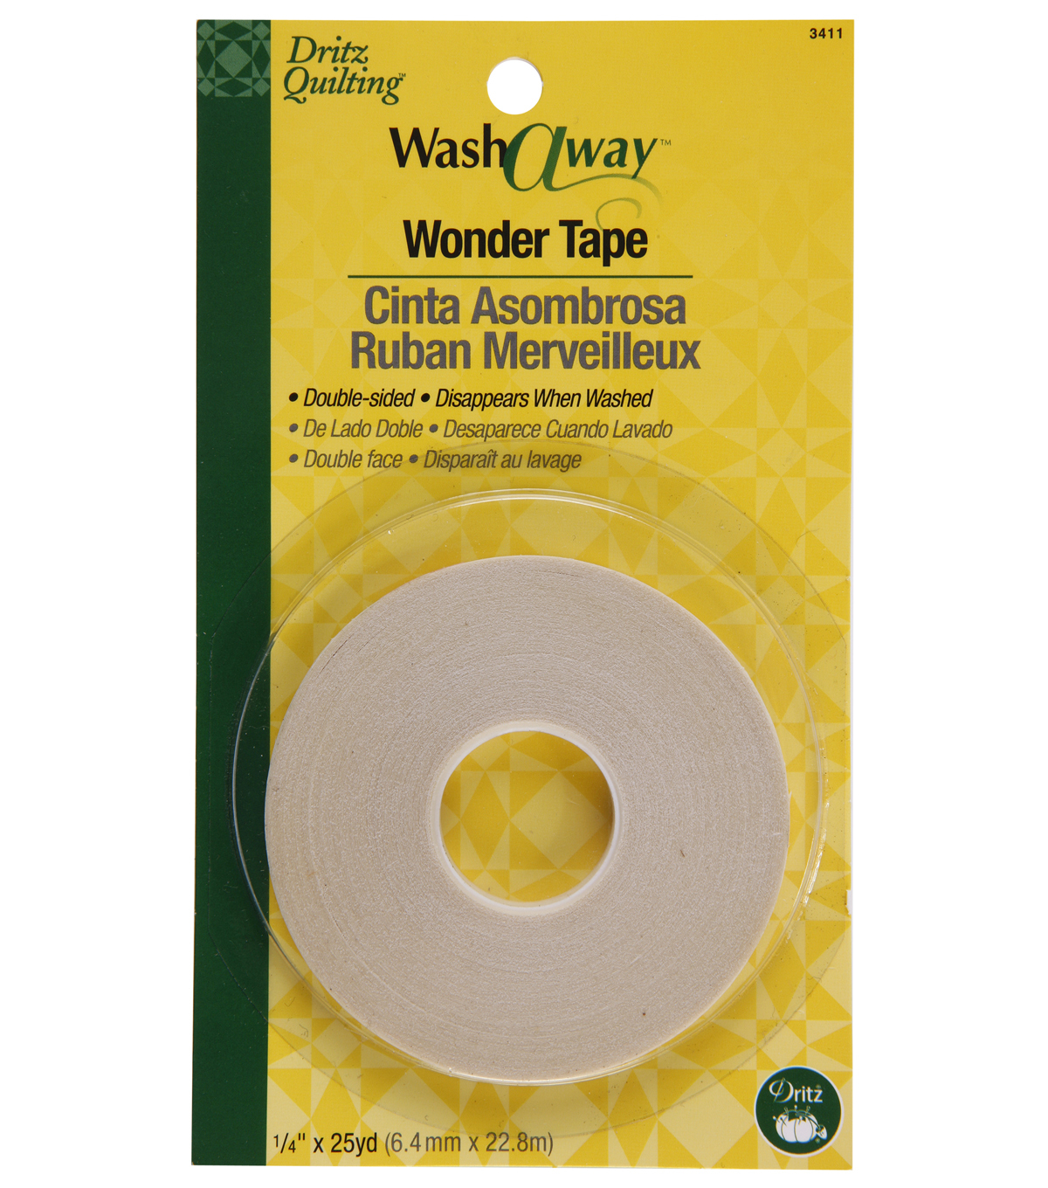

- Sew with a triple stitch on the first premarked line between the ¾” lines. Making sure that your ¾” lines on the side meet with the new stitched line. If a gap gets left it can let pellets leak out.
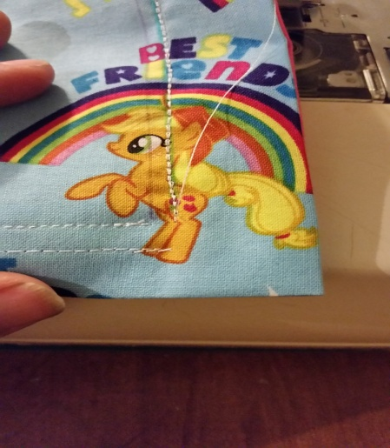
- Now finish the rest of the top stitching around the top of the blanket making sure to meet up with the previously stitched lines.

- Enjoy the success of completing a weighted blanket.

If you have any questions feel free to email me at weightedcomfortforkids@gmail.com.

