Materials needed: Fabric for front and back (print one side and solid the other), cutting mat, rotary cutter, thread, pellets, large bowl (think huge mixing bowl), measuring cup, kitchen scale, dissolvable tape - optional.

Sizes will be color coded and listed like this 2lb (3lb, 4lb)

- Fabric should be cut at 18”x 21” (18”x 21”, 18” x 21”)
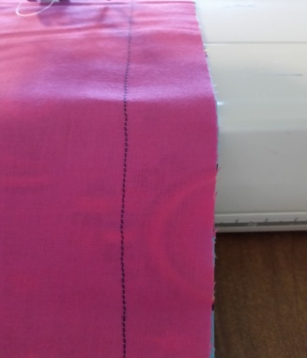
- Sew it right sides together on three sides with a 3/4” seam. Leave about 1” on the top of each side to allow for finishing the top.
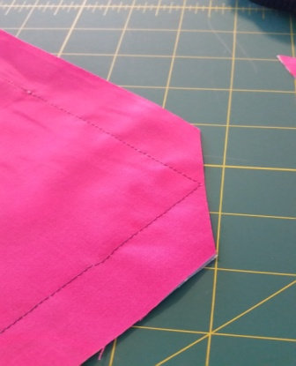
- Cut the bottom of the two corners on an angle to allow for a crisp corner.

- Turn right-side out and iron.

- From the top mark 1” down. This is so you know where to start and stop all of your stitches.

- Starting at the top of one side, at your premarked line, sew a top stitch, using a triple stitch/stretch stitch/knit stitch around the three already sewn sides. This stitching needs to be right on the edge of the fabric (no more than a 1/8" seam).
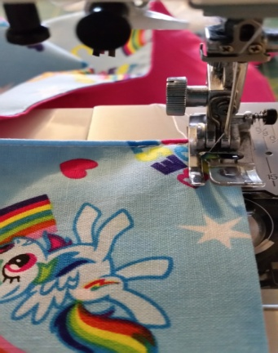

- Sew a second stitching line, ½” from edge, around all three sides again using the triple stitch/stretch stitch/knit stitch.
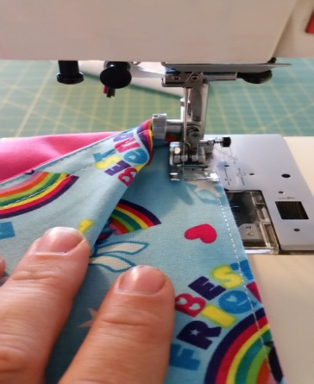
- Measure the length between both of 1/2” triple stitch line on the short side. Take that number and divide it by 3 (3, 3). This is the spacing to mark the lines for the columns.

- Mark the lines for the columns.

- Stitch the columns with a triple stitch/stretch stitch. This completes the shell of the lap pad.

- Measure the length between 1/2” triple stitch lines and the premarked line. Take that number and divide it by 2 (2, 2). This is the spacing for the rows.

- Mark the lines for the rows.

- Add 5 1/3 oz (8oz, 10.5oz) to each column by using a kitchen scale to weigh the pellets out. This will roughly be 1 cup (1 2/3 cup, 2 1/3 cup) of pellets if they weigh 1.6oz per 1/3 cup. We either use Quality Poly Pellets from qualityplasticpellets.com or buy bags from JoAnn's when on sale.

- Triple stitch/stretch stitch on the first row from the bottom line.

- Continue the previous two steps for next 1 (1, 1) row.

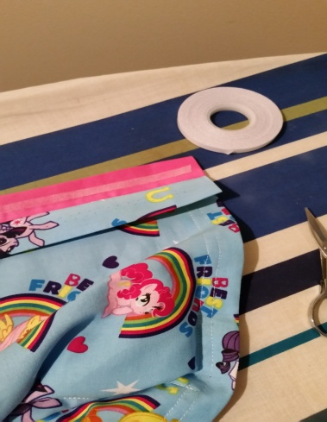
- The last row, fill each column with pellets. Fold down the extra fabric to the already stitched edge lines and columns, and iron it to get a crisp edge. You may use a dissolvable tape between the front and back fabrics to help keep the pellets in.
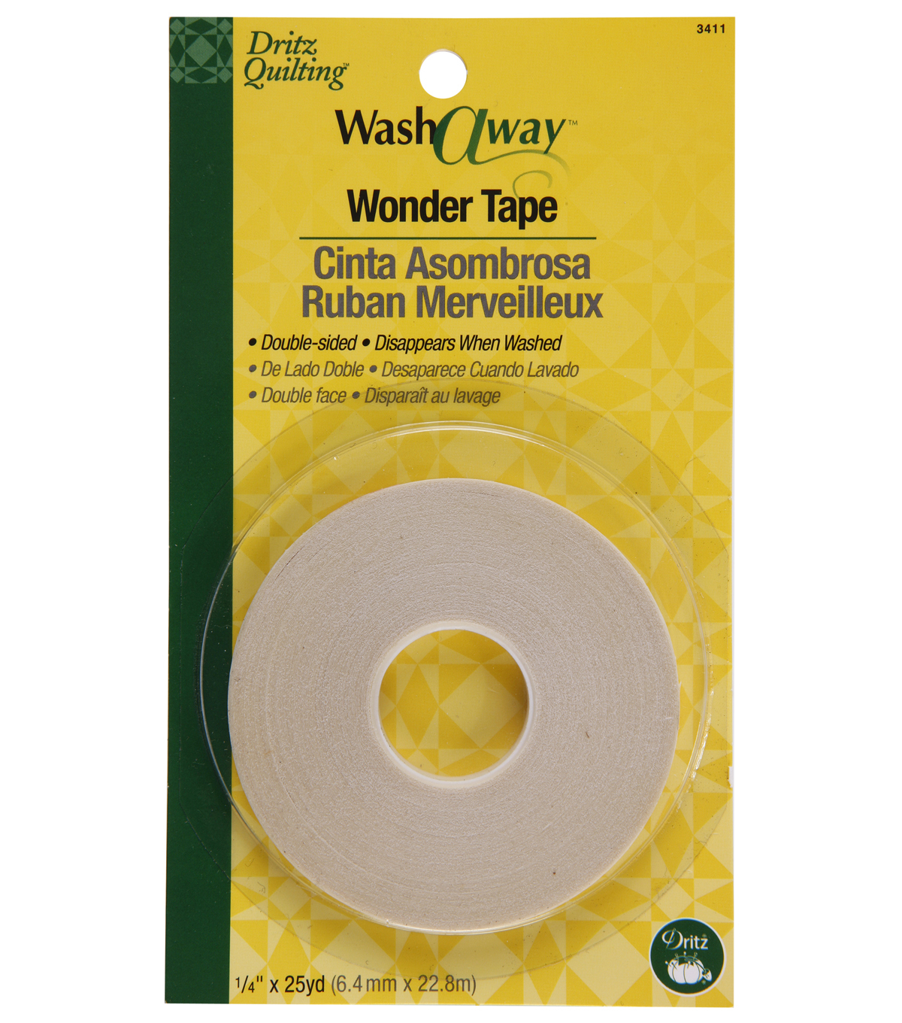

- Sew with a triple stitch on the first premarked line between the 1/2” lines. Making sure that your 1/2” lines on the side meet with the new stitched line. If a gap gets left it can let pellets leak out.
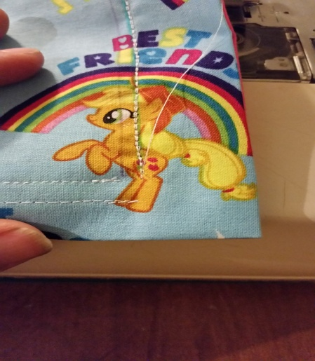
- Now finish the rest of the top stitching around the top of the blanket making sure to meet up with the previously stitched line.

- Enjoy the success of completing a Lap pad.

If you have any questions feel free to email me at weightedcomfortforkids@gmail.com.

